**SPCM LAB 5**

**Lab Exercise 5–Provisioning an S3 Bucket on AWS**

**Exercise Steps:**

**Step 1: Create a New Directory:**

Create a new directory to store your Terraform configuration:

**Step 2: Create the Terraform Configuration File (main.tf):**

Create a file named main.tf with the following content:

terraform {

required_providers {

aws = {

source = "hashicorp/aws"

version = "5.31.0"

}

}

}

provider "aws" {

region = "us-east-1" # Replace with your preferred region

access_key = "your IAM access key" # Replace with your Access Key

secret_key = "your secret access key" # Replace with your Secret Key

}

This file sets up the Terraform AWS provider.

**Step 3: Create a Terraform Configuration File for the S3 Bucket (s3.tf):**

Create another file named s3.tf with the following content:

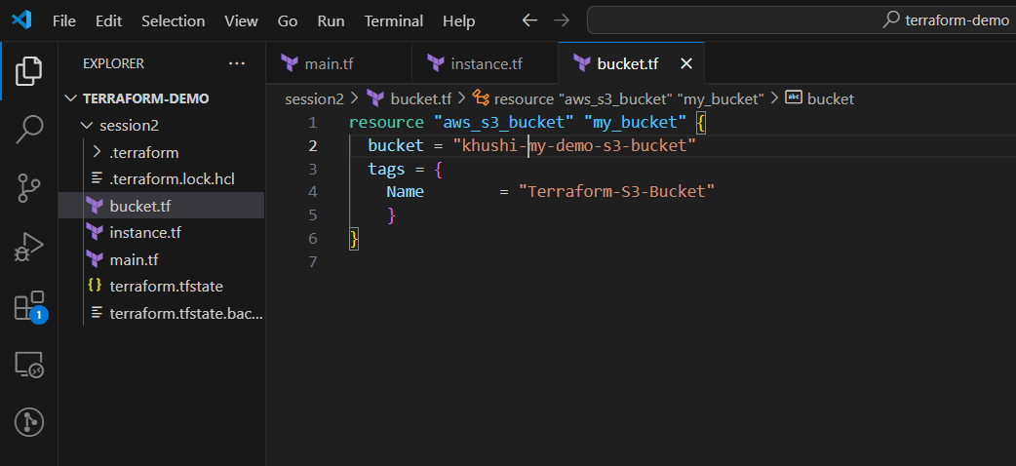

**Step 5: Review the Plan:**

Preview the changes Terraform will make

